Installation of java in MAC

- Navigate to http://www.oracle.com/technetwork/java/javase/downloads/index.html

- Click on 'DOWNLOAD' button under jdk.

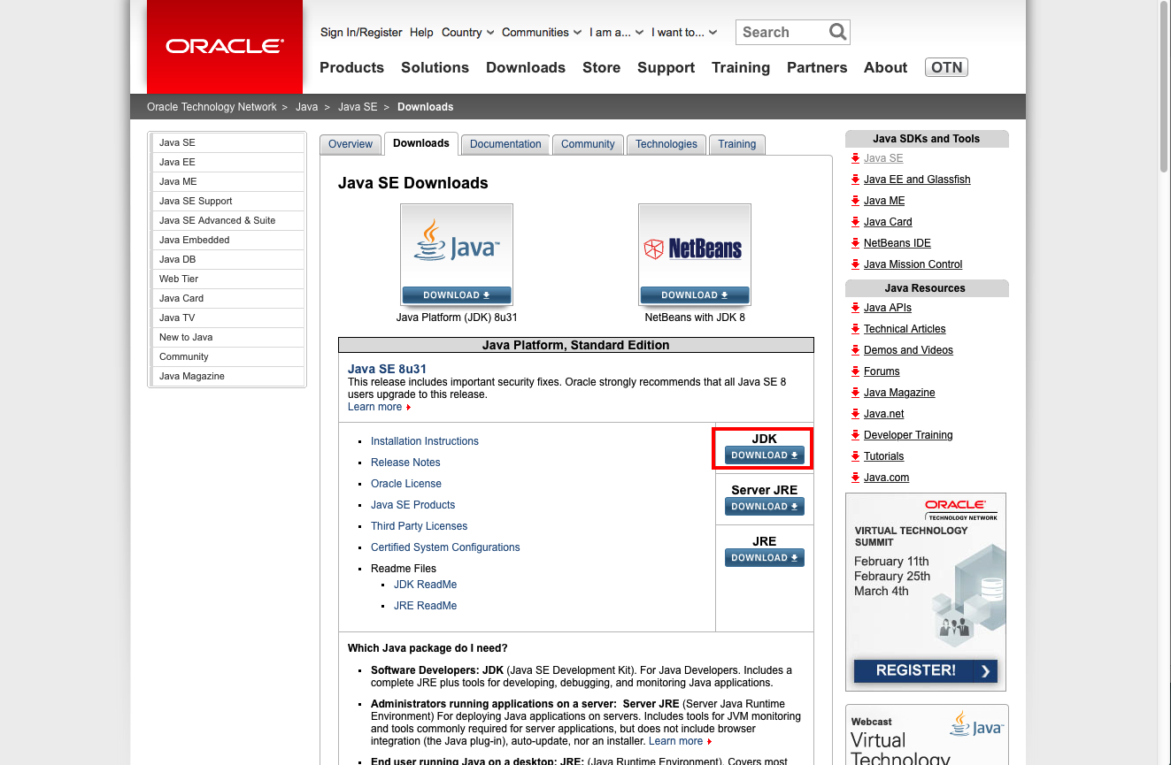

- Click on 'Accept License Agreement' radio button, then click on '.dmg' file beside MAC OSX

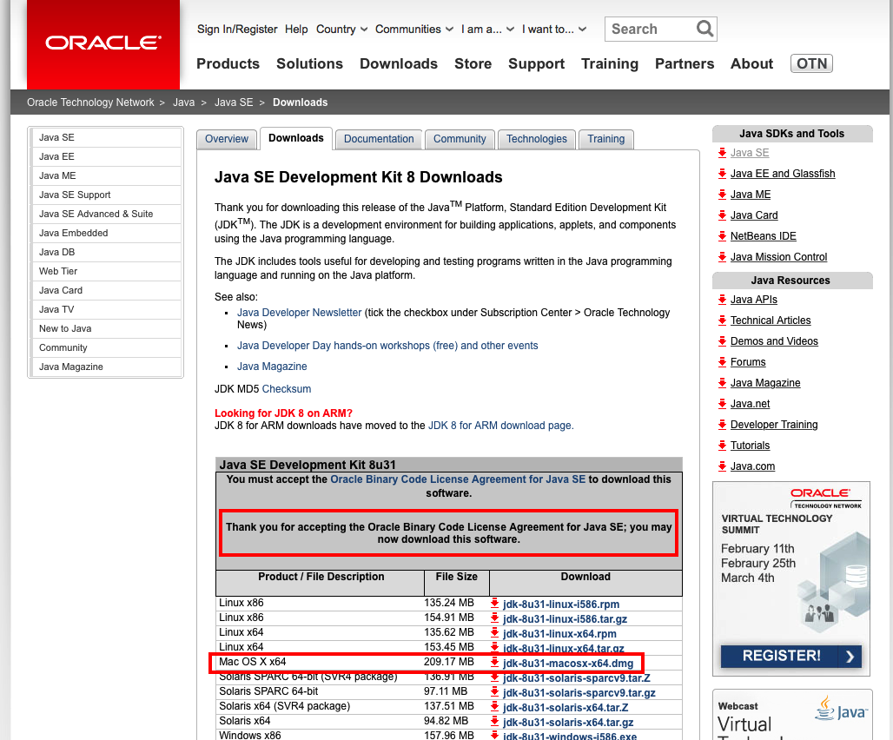

- Now the dmg file downloading starts, it gets downloaded to 'Downloads' folder.
- Double click on downloaded .dmg file, now double click on '.pkg' icon
- Follow the installation steps in the install dialog

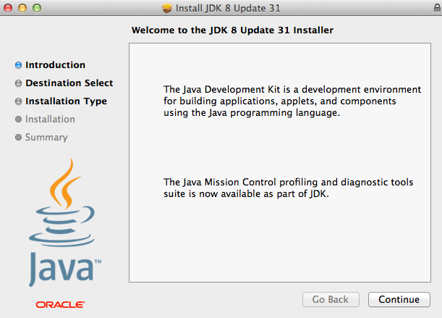

- If prompted with following dialog while installing the software\
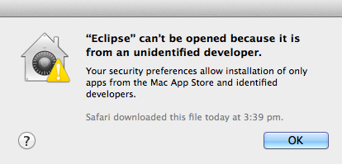

- Open System Preferences → Security & Privacy option gets displayed to allow the changes to be applied or not then provide the required credentails and proceed for installations

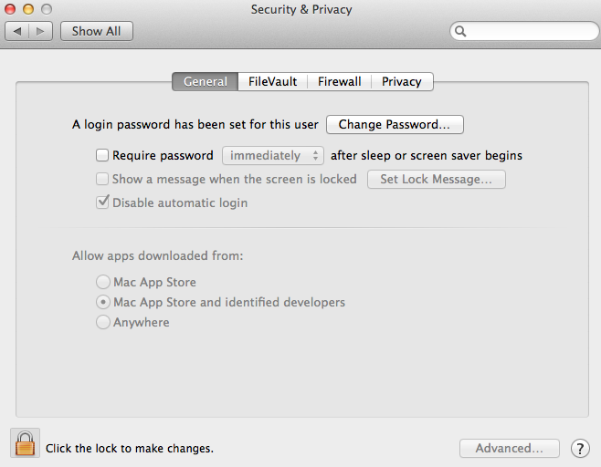
- After installation is done succesfully ,verify java version by opening the terminal and typing java -version

